**Dynamo DB**

**\*using free tier account**

1. **Creating Table Name , Partition key , and sort key**

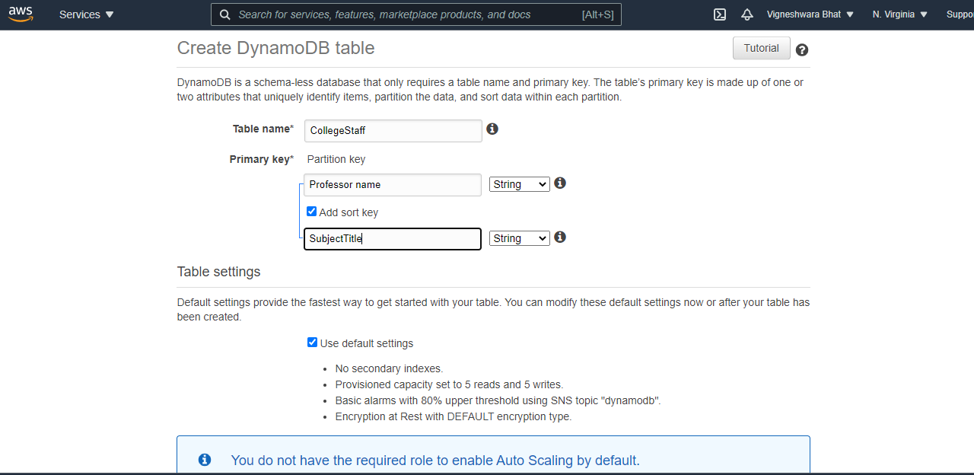

1. On the **Items** tab, choose **Create item**.

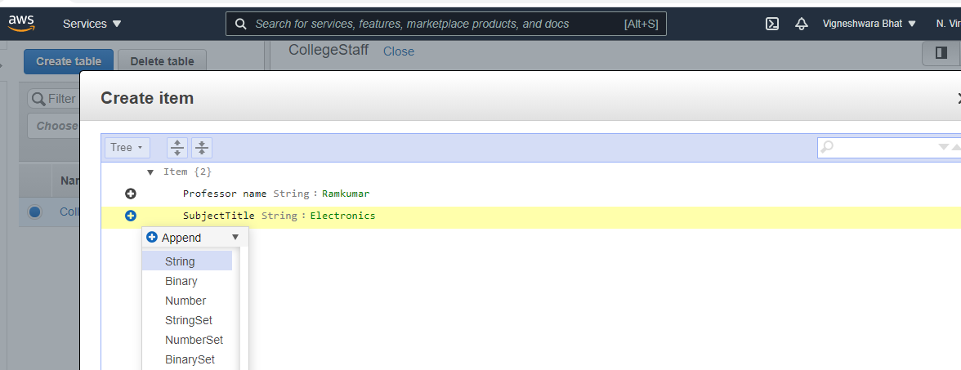

1. Creating Item

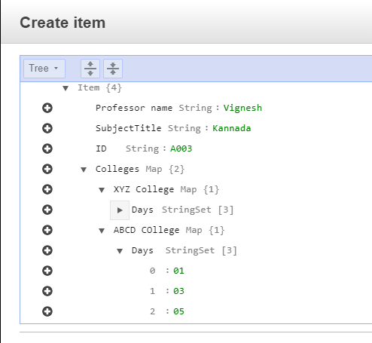

1. **Read Data from DynamoDB**

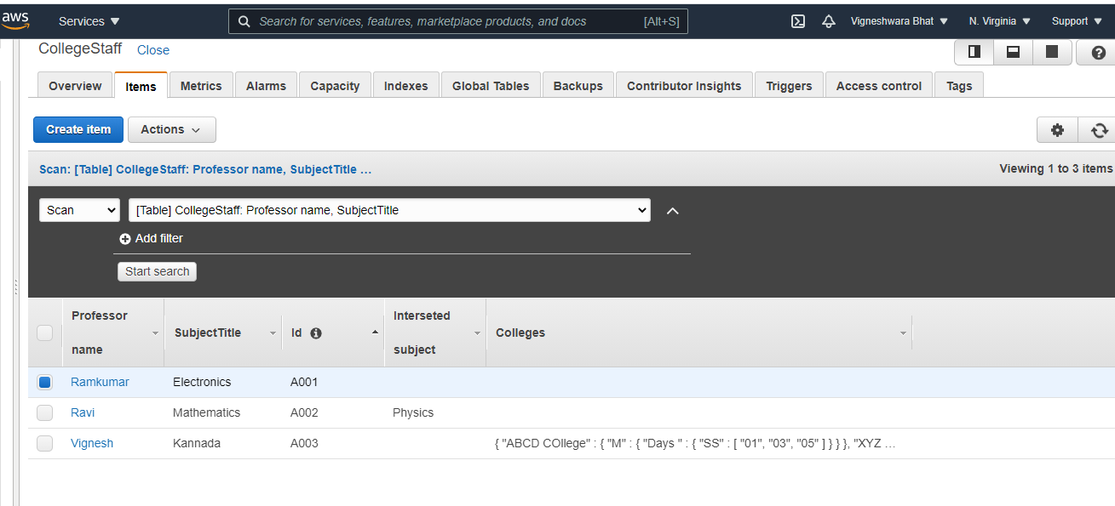

1. **Query Data**

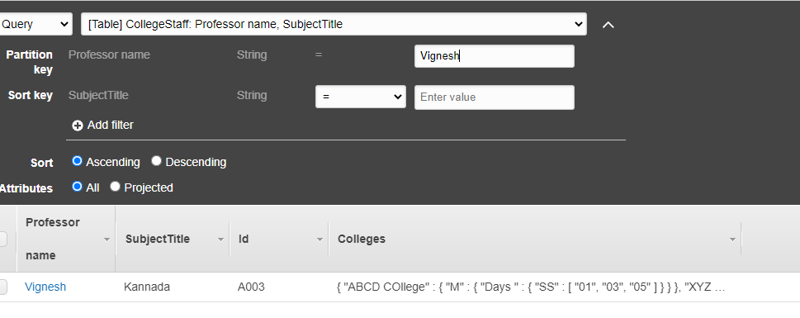

1. PartiQ editor for DynamoDB

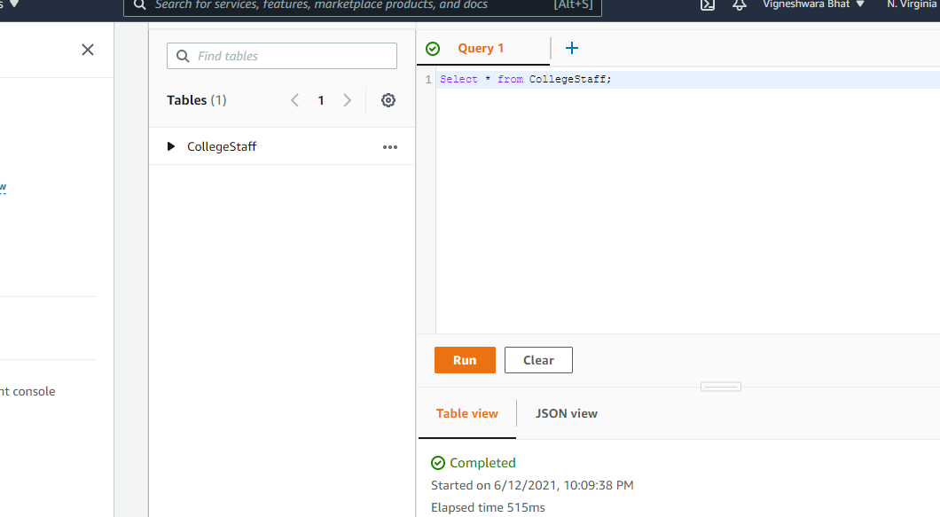

1. **JSON view to see the JSON form of output**

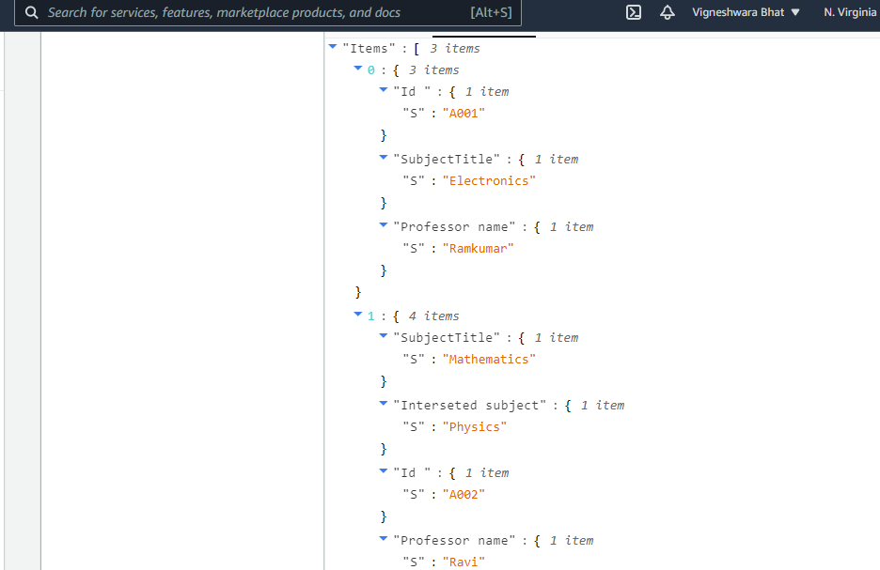

1. **Export the dataoutput to S3**

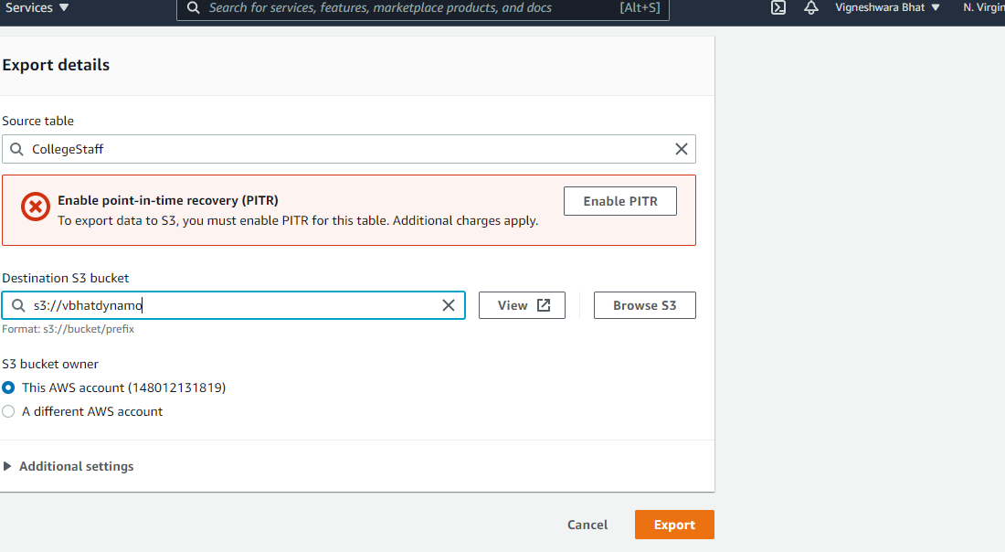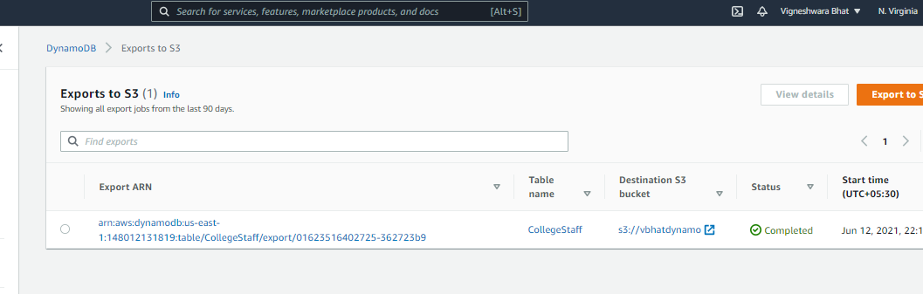

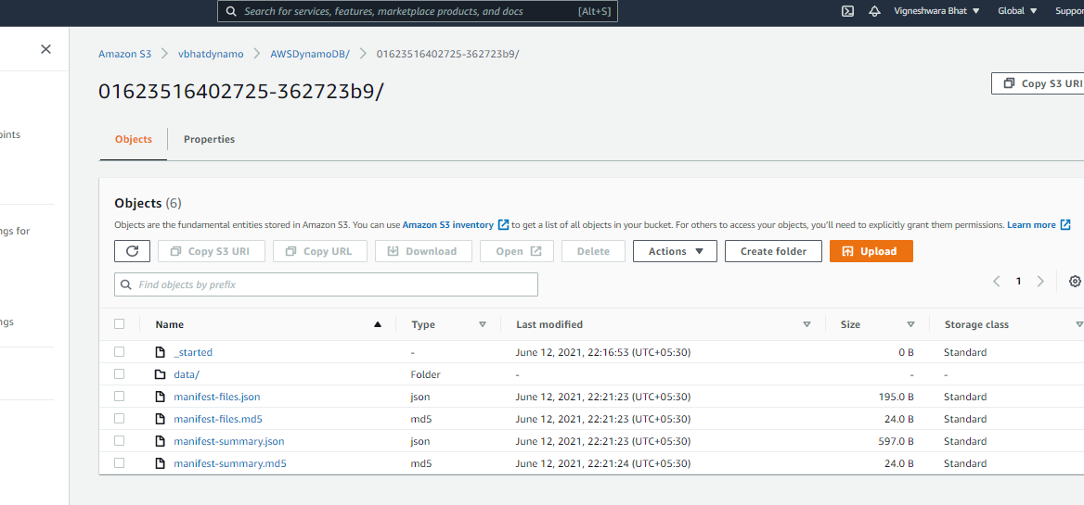

1. **Select uploaded data from bucket in S3** 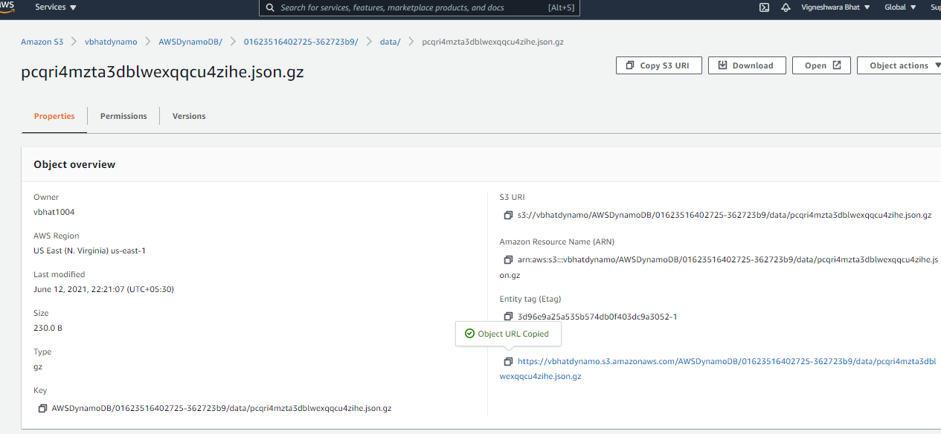
2. **Download using S3 link** 